# Project Stars: manual

While the Project Stars simulation isn’t an overcomplicated mess of algorithms and functions, a slight introduction might be necessary for any user that doesn’t want to fail miserably in the first few tries. So, if you just want a quick five minute summary of the simulation (and don’t want to read a 40-pager about all the goals, definitions and code-analysis), this if for you.

# Starting up

When you start up Project Stars, you will start with a similar screen as the one down below (picture 1). The three available buttons are pretty self-explanatory: “Start” will initiate a new simulation, “Load” will start up the simulation from where it was previously left (if the user saved it of course) and finally, “Exit” will close the screen. Let’s click on start and get going.

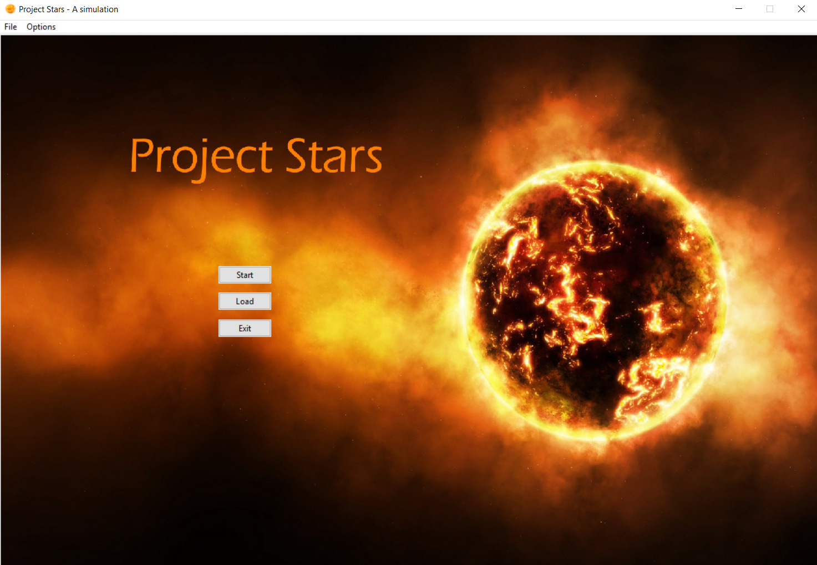

Picture 1: Main menu

In the centre of the screen, you can see the star system and the planets orbiting it. As the instruction message states, the user can click on the planets (the rotating red orbs on the white circles) to see their properties (picture 2).

1. In the top left corner, a “file” button can be found, which contains the buttons “save” and “load”. Saving is only possible when the actual simulation has begun, so only the load button will be highlighted.
2. 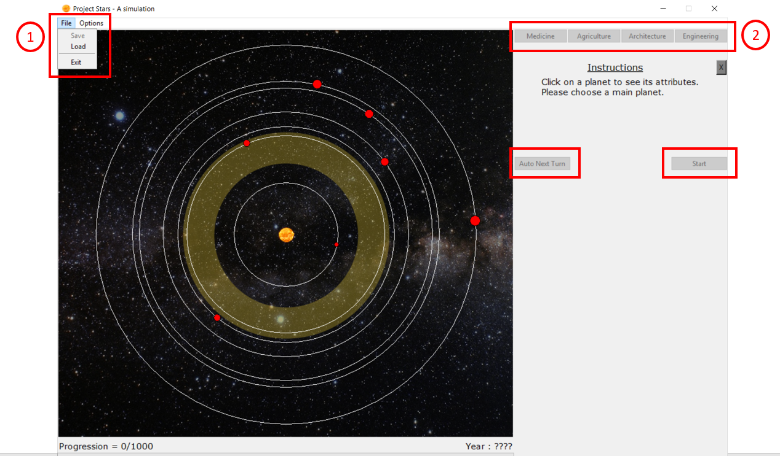On the right side, a number of buttons can be seen, but these are not highlighted at the moment. They will become available as the simulation progresses.

Picture 2: Simulation start

# Planet selecting

When a planet has been selected, all of the basic information will be shown to the user in a new information panel on the right (picture 3) This contains the planet’s name, distance to the central star, radius, percentage of the surface that is habitable landmass, a percentage of how good the atmosphere is in comparison to an ideal atmosphere, temperature in degrees Celsius and a variable planet quality. This variable is a combination of all the above, which determines the overall quality of the planet. The golden zone in the centre is known as the “Goldilock zone”. Because of the distance from this zone to the star, the circumstances of the planets inside tend to be better suitable to sustain life than the planets that are closer or further. For the first few playthoughs, we highly recommend using one of these planets.

When the planet of your choice has been selected, click the button underneath the variables to confirm. A pop-up screen will appear, accept again. From this moment on, this planet is your main planet.

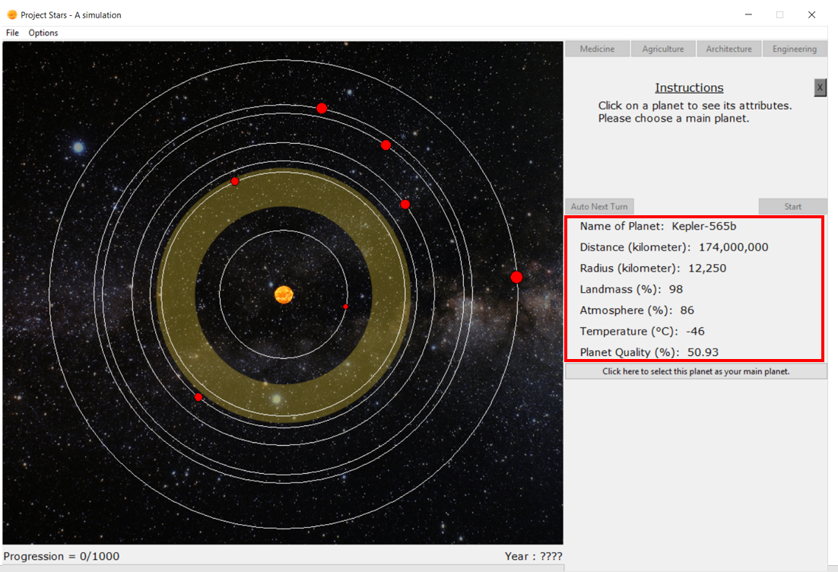

Picture 3: Planet variables

# Setting technologies

After the main planet has been set, another pop-up screen will appear (picture 4). This will ask the user to give his organism a basic 12 points in the technologies that could be seen on the starting screen, except for engineering. Technologies provide assistance to the organism, be it by improving the organism or gaining resistance against the possible disasters that could strike the planet. The three “supportive” technologies (medicine, agriculture and architecture) have a cap of 15, while the “main” technology engineering has a cap of 30. Each technology can be further researched as the simulation progresses. The influence technologies have are explained in the following table.

|  |  |
| --- | --- |
| Medicine | Mostly used to keep your organism healthy, medicine is the only technology that will increase your population health, thus resulting in a higher life quality. Also responsible for a small fraction of your progression. |
| Agriculture | As your organism needs to feed itself to survive, it will produce food on the usable landmass of the planet. Upgrading agriculture will make the organism more capable of recovering the landmass, should it be affected by a disaster. More food means that more productive organisms can live, thus increasing your population. Also gives knowledge about how to fight disasters that damage the atmosphere. |
| Architecture | Similar to agriculture, architecture ensures the organism can recover faster from disasters that affect the usable landmass. Also has a decent impact on the progression, not as much as engineering, but more significant than medicine. |
| Engineering | The main technology of the simulation. Engineering unlocks secrets of the universe for the organism, needed to create a spacecraft that can evacuate the species from the planet before it’s too late. Has a massive impact on the progression in comparison to the other technologies, while also slightly boosting the life quality though luxury products. |

A wise user can already start preparing his organism, depending on the planet that was chosen. Living on a small planet with a limited amount of landmass? Focus on agriculture and architecture to prevent hunger. Poor atmosphere? Agriculture will prevent a complete breakdown, should a disaster hit the atmosphere, etc.

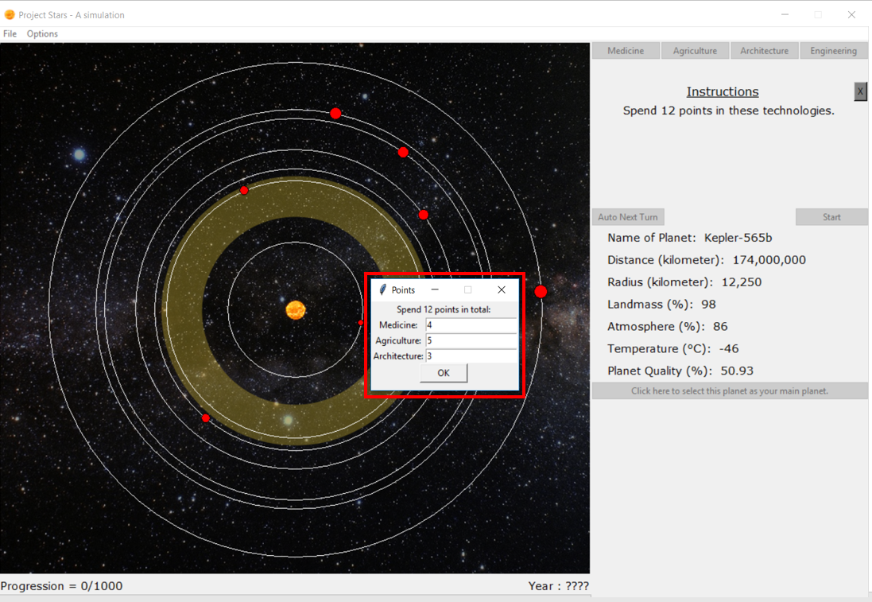

Picture 4: Setting starting technologies

Setting research focus

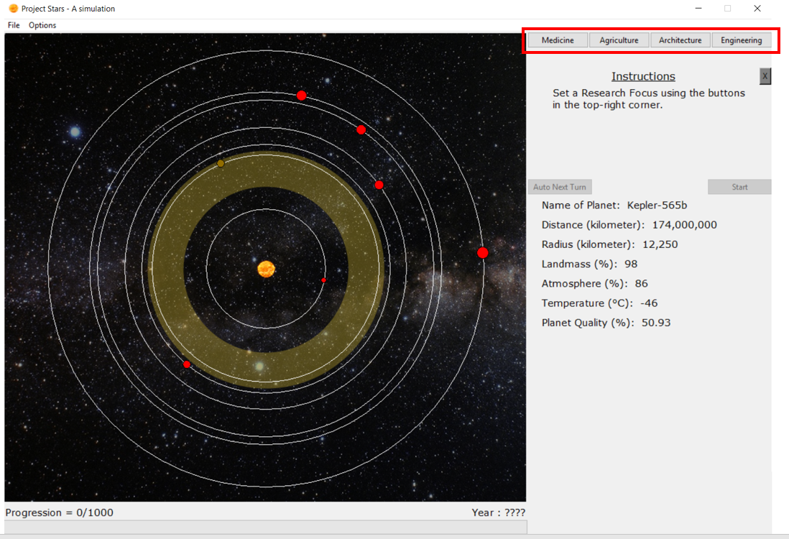

Picture 5: Setting research focus

Now that the base technologies of the organism have been set, the starting research focus must be appointed. Click on one of the technology buttons in the upper right corner, which are now available (picture 5).

Simulation start

Now that everything is ready, the simulation is ready to start. The start-button is now available, click it. Some changes were made: the planets started rotating in their respective courses and some extra information has been made available: the amount of turns remaining, turns left for technology advancement, the usable landmass, (population) health, life quality, population and all of the technologies (picture 6)

* Turns remaining: each simulation consists of 100 turns. With each turn, the population will grow or shrink, life quality can change and all kind of events can happen. The turns will only progress when the “next turn” button is pressed, so the user has as much time as he likes to adjust to the new situation.
* Turns left for technological advancement: As explained above, technologies can increase over the course of the simulation. It takes 5 turns of consecutive research to elevate a technology to a higher level (so should the research focus change from one technology to another, all progress towards another level in the former technology will be permanently lost). This number shows the amount of turns left until the elevation takes place.
* Usable landmass: this number represents the percentage of the landmass that the organism currently has available.
* Population health: The health of the population. Disaster can bring this number down, while it will slowly recover afterwards (depending on the medicine technology). Since a sick population has a hard time working on a way to escape from the planet, bad health will cause a slowdown in the progression.
* Life quality: Perhaps the most important value in the simulation. Life quality depends on your usable landmass, health, architecture and engineering. It represents the mental state of your organism as a whole. This is the most important factor of your population growth, while also playing a major role in the progression.
* Population: The current population.
* Technologies: The current technology levels

Next to some of the variables, there will be brackets with two minus signs inside. As the progression runs, the changes relative to the previous turn will be shown between these brackets.

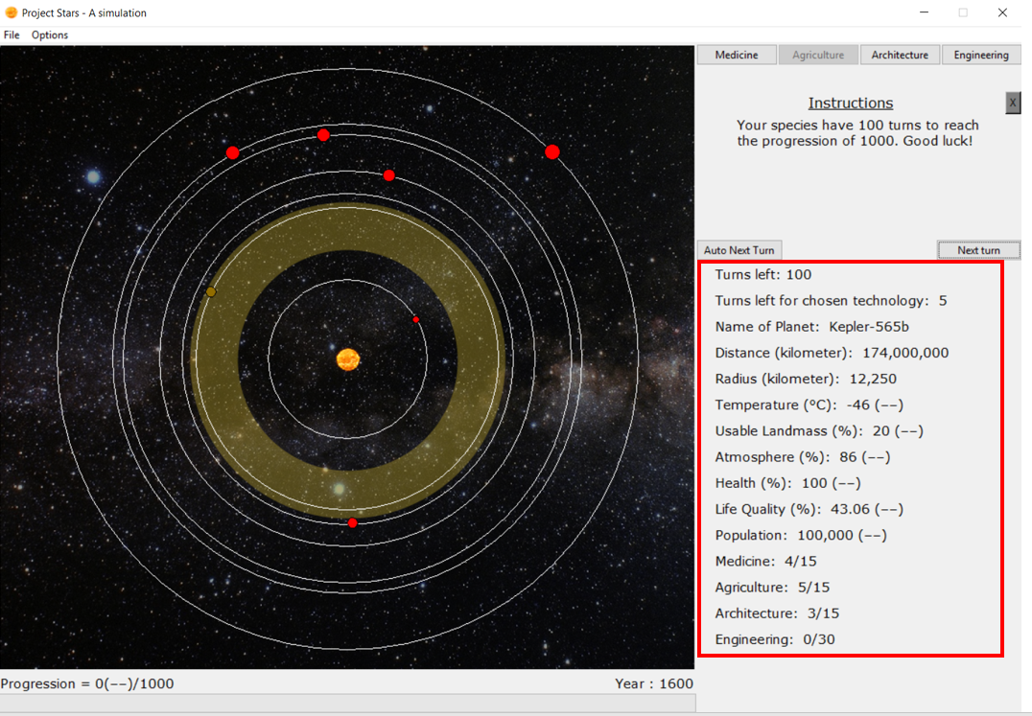

Picture 6: Extra variables

Events

As the simulation progresses, certain events will at random be thrown at the user. Some of these are useful (Breakthroughs), others might be rather annoying (or devastating, depending on the event).

Breakthroughs: (picture 7) These events are helpful to the organism. Depending on the event, one of the four technologies will get an instantaneous boost of 1. This is completely independent from the current research or tech levels already accumulated.

Disasters: (picture 8) These events will set the organism back a few steps. It’s the simulations way of trying to prevent the user from getting of the planet. Unlike breakthroughs however, the chance of disasters depends on the level of progression the organism have. Simulations where the progression has furthered a lot will encounter more and deadlier disasters. The most dangerous disaster will even destroy the planet, so be careful. While the main objective is to escape, rushing it might leave the user with little defence against the disasters that might lie ahead.

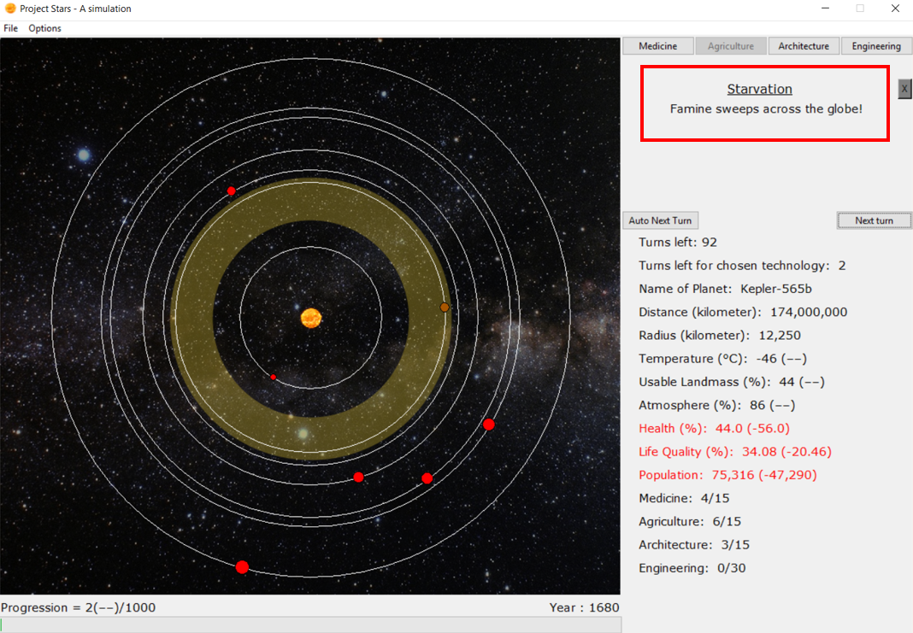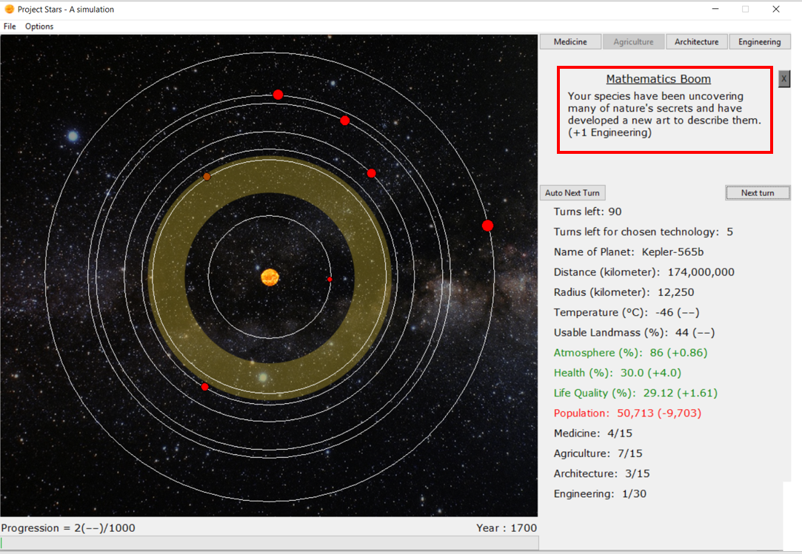

Picture 8: Disaster strikes

Picture 7: Breakthrough achieved